Disney will build a new park in the UAE  アラブ首長国連邦に新しいディズニーランドを建設予定 ［2025年 5月第3週］ | 
- Disney will build a new park in the UAE.
It will be the first Disney park in the Middle East,
and the seventh in the world. ★音読チェック( )
- The UAE is close to many countries,
so many people can visit the park by plane. ★音読チェック( )
- The UAE is a rich country with oil and gas.
Many tourists will come to the park.
Hotels, restaurants, and shops will be busy. ★音読チェック( )
the Middle East中東 close to ～：～に近い tourist観光客 ★( )

Q1 Where is the UAE? Find the country in the world map. □Done!
Q2 下の空欄にあてはまる数字を答えましょう。
UAE（アラブ首長国連邦）にディズニーランドを作ったら、
中東で（ ）、世界では（ ）番目のディズニーランドになります。

Q3 Choose 3 countries in the Middle East from the list below.
［ Turkey Canada Saudi Arabia France Kenya Iran ］

Q4 What is the capital of the UAE? （UAEの首都は？） （ ）

Q5 How long does it take from Tokyo to Abu Dabi by plane? ― It takes about ( ) hours.

Q6 Why is the UAE a rich country? ― Because it has a lot of ( ) and ( ).

Q7 What places will be busy when tourists come? Write three places.
UAEに観光客がたくさん来たら、どの施設が忙しくなりますか？ 3つ書きましょう。
（ ）（ ）( )

◆UAEクイズ◆
1) UAEの宗教は？ ①キリスト教 ②イスラム教 ③仏教
2) UAEの公用語は？ ①スペイン語 ②英語 ③アラビア語

- But there is a problem.
Summer is very hot in the UAE. ★音読チェック( )
- Still, many people are excited to see the new park!
It will take more than five years to build it. ★音読チェック( )

Q8 How hot can it be in the UAE in summer?
① 30°C ② 40°C ③ 50°C

Q9 How long will it take to build the Disney park? ― It will take more than ( ) years.

Q10 Do you think it is a good idea to build Disneyland in the UAE? Why or why not?

Q11 Have you ever been to Tokyo Disneyland/DisneySea? □ Yes, I have. □No, I haven’t.
Q12 Who is your favorite Disney character?

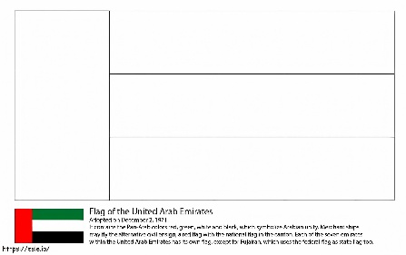  https://esle.io/ja/coloring-page/flag-of-the-united-arab-emirates  ★次の文を暗唱しよう！  □Disney will build a new park in the UAE.  □The UAE is a rich country.  □Summer is very hot in the UAE. | 🌍 Disney Theme Parks Around the World  No. Opening Year Location Country  1 1955 Anaheim, California the U.S.  2 1971 Orlando, Florida the U.S.  3 1983 Urayasu, Chiba (near Tokyo) Japan  4 1992 Marne-la-Vallée (near Paris) France  5 2005 Lantau Island China (Hong Kong)  6 2016 Pudong, Shanghai China  7 TBA Yas Island, Abu Dhabi the UAE  ※TBA: To be announced
Q13 Where do you think the next Disneyland should be built?

